Calculated Columns:
- Category Type = 'Order Details'[Category] & " " & 'Order Details'[Sub-Category]
- Revenue per Order = 'Order Details'[Amount] * 'Order Details'[Quantity]
- Sales Category = IF('Order Details'[Amount] > [Avg Revenue] , "Above Average", "Below Average")
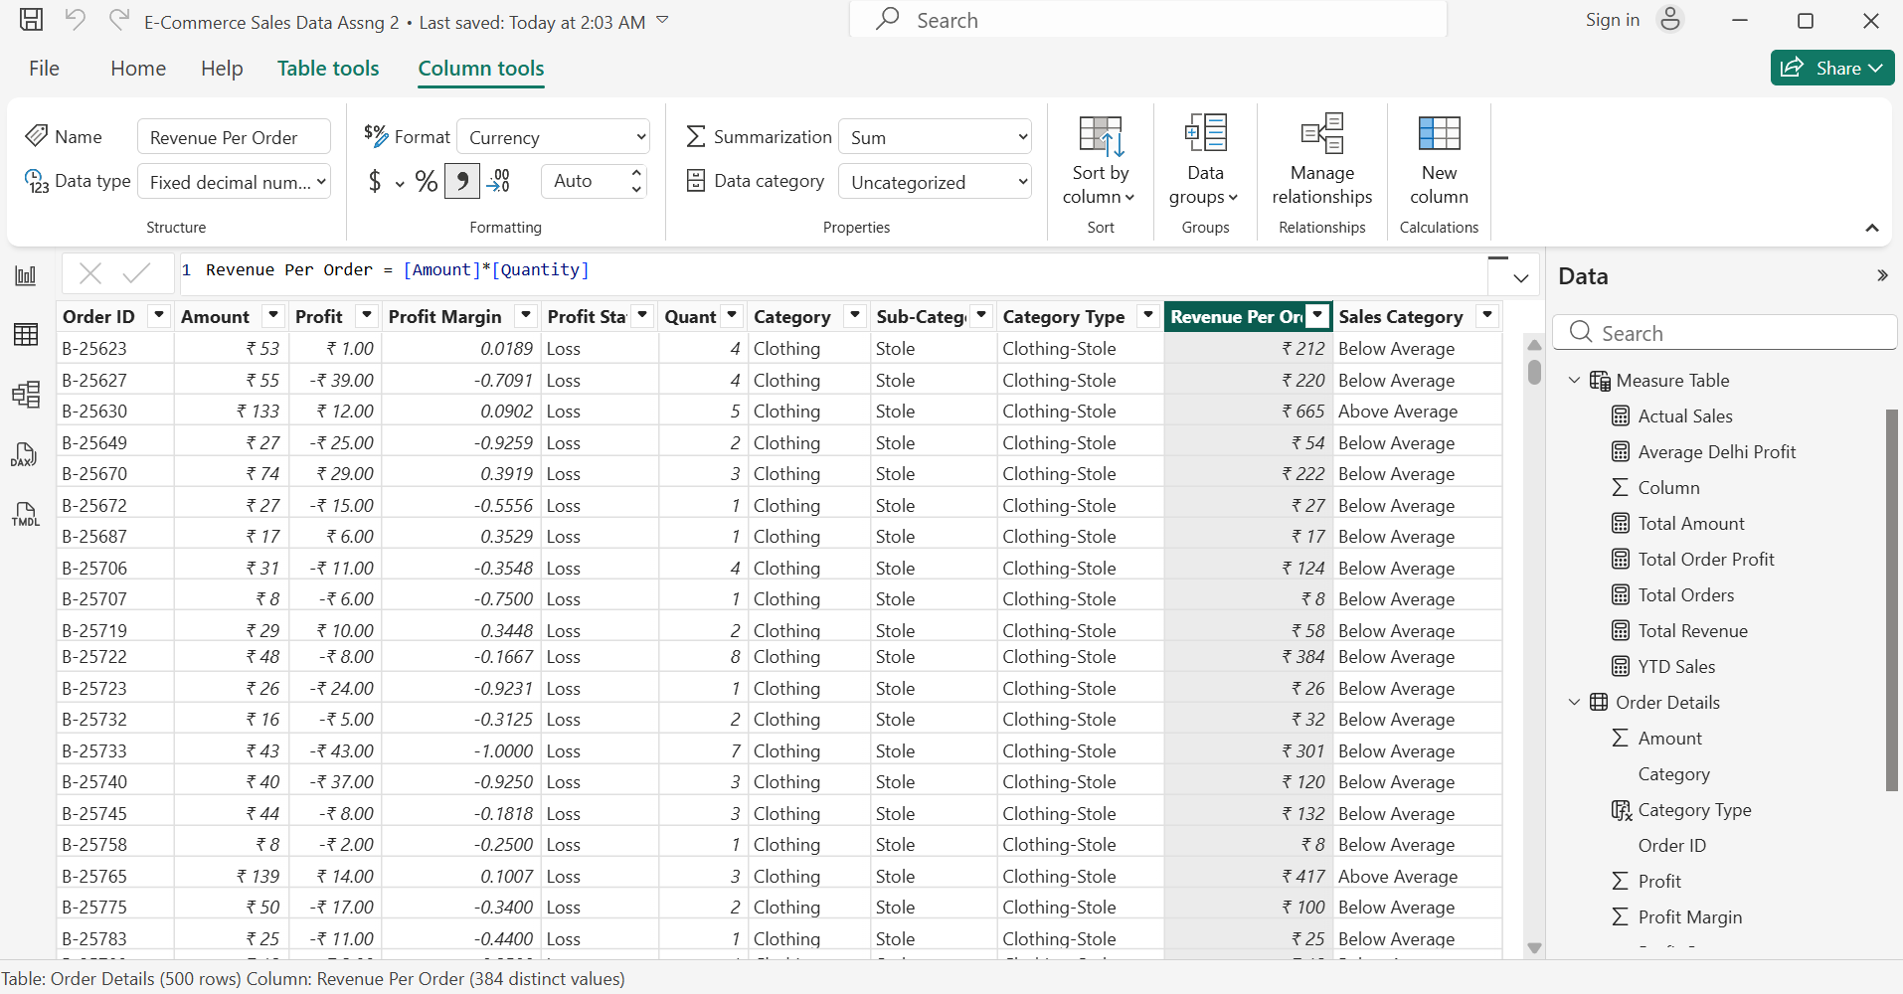

Calculated Measures:
- Order Count = COUNT('List of Orders'[Order ID])
- Avg Profit Delhi = CALCULATE([Avg Profit], FILTER('Order Data','Order Data'[City] = "Delhi"))
- Current YTD = TOTALYTD ( [Total Revenue],'Calendar'[Date])

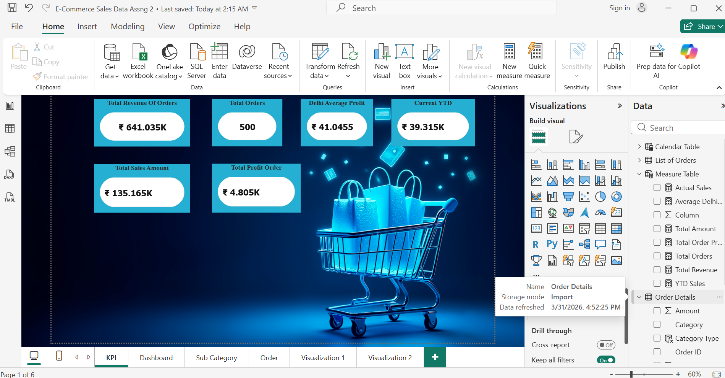
Data Visualization:
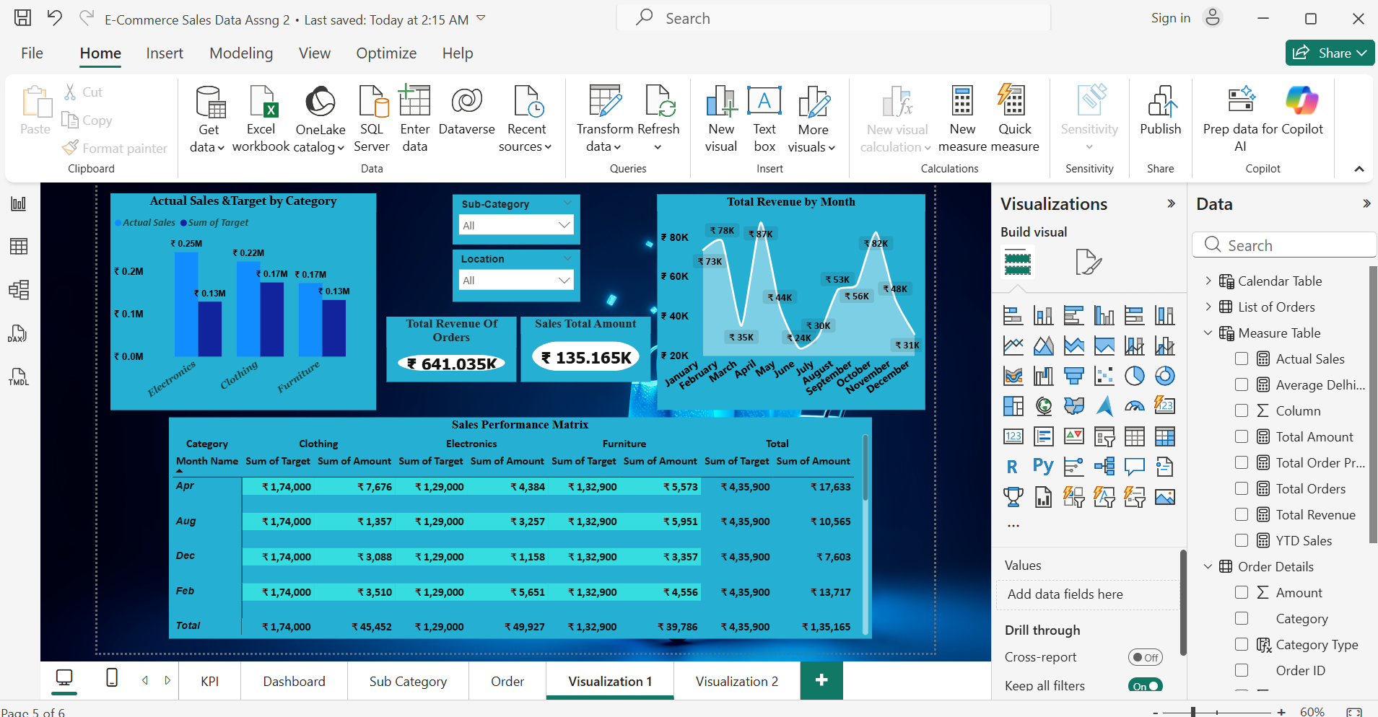
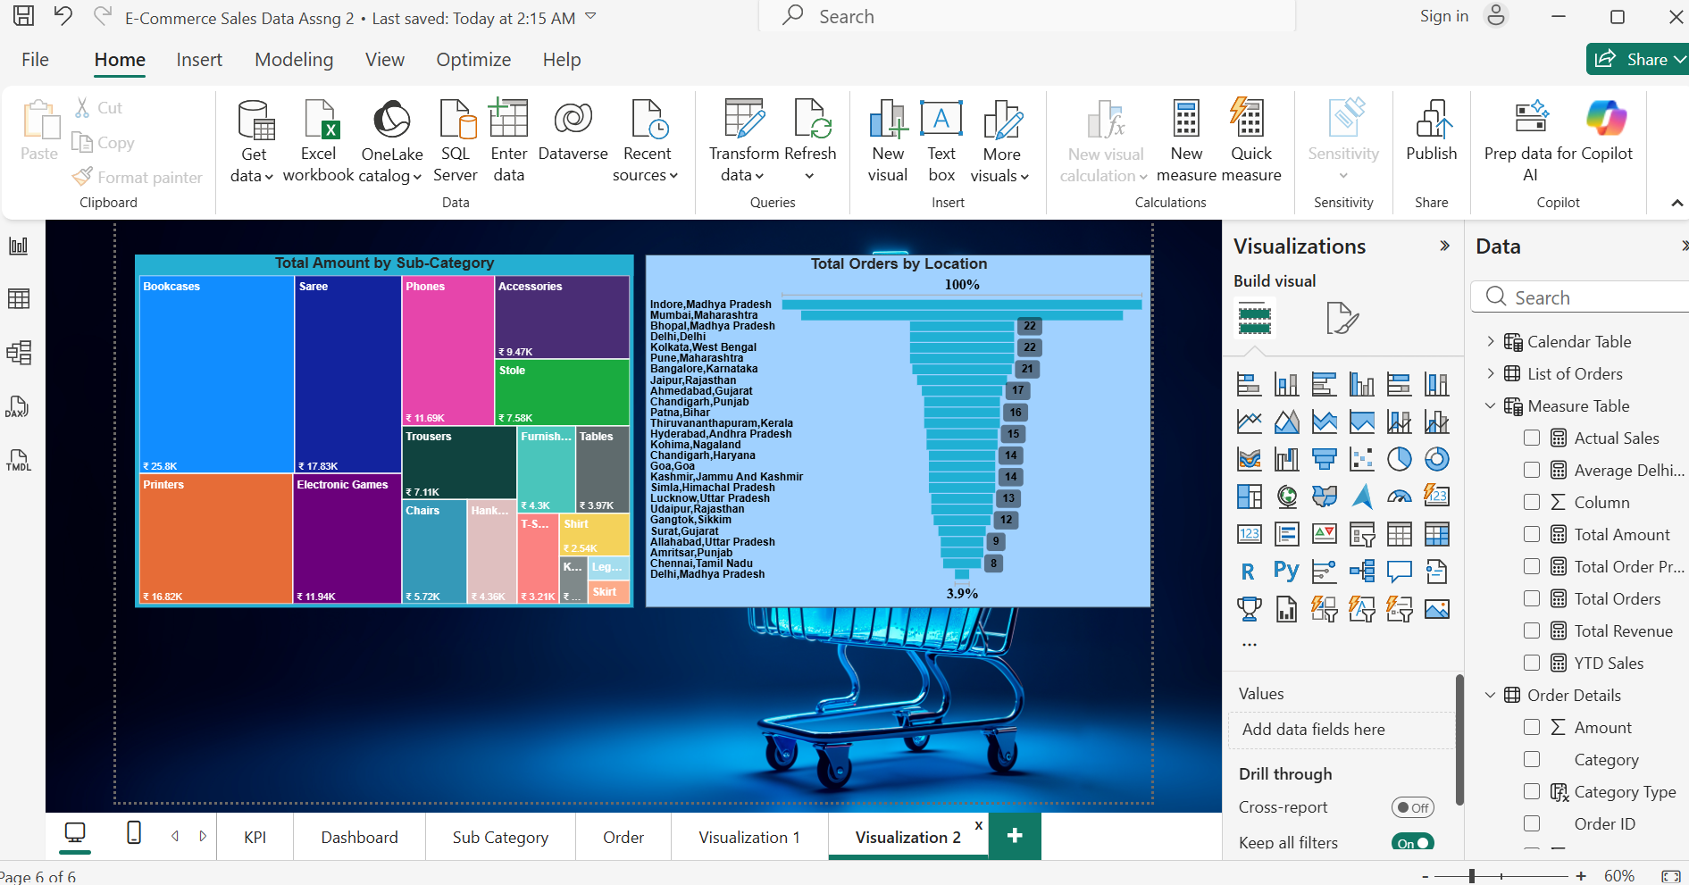
DASHBOARD
